## **Task 1**

Share the screenshot of the model as requested in the document.

Answer screenshot

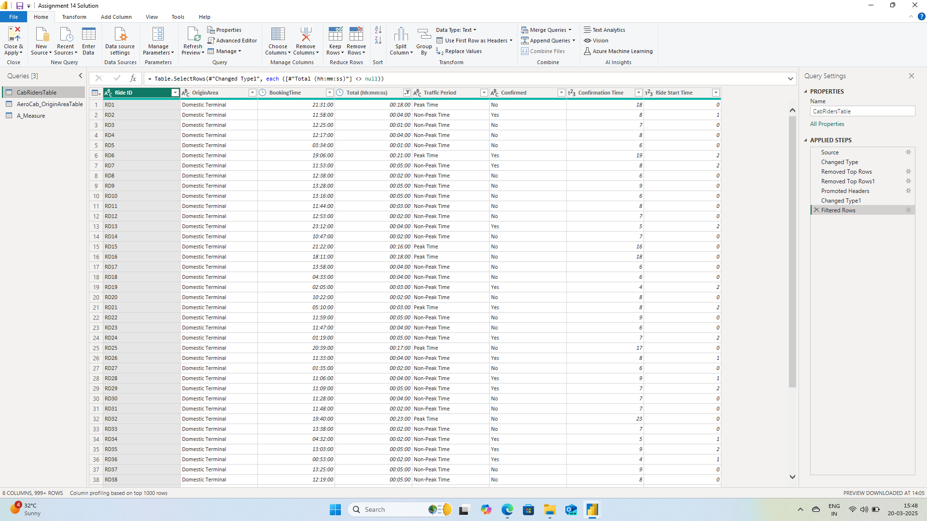

**Task 2**

Share the screenshot of the dashboard as requested in the document.

Answer Screenshot

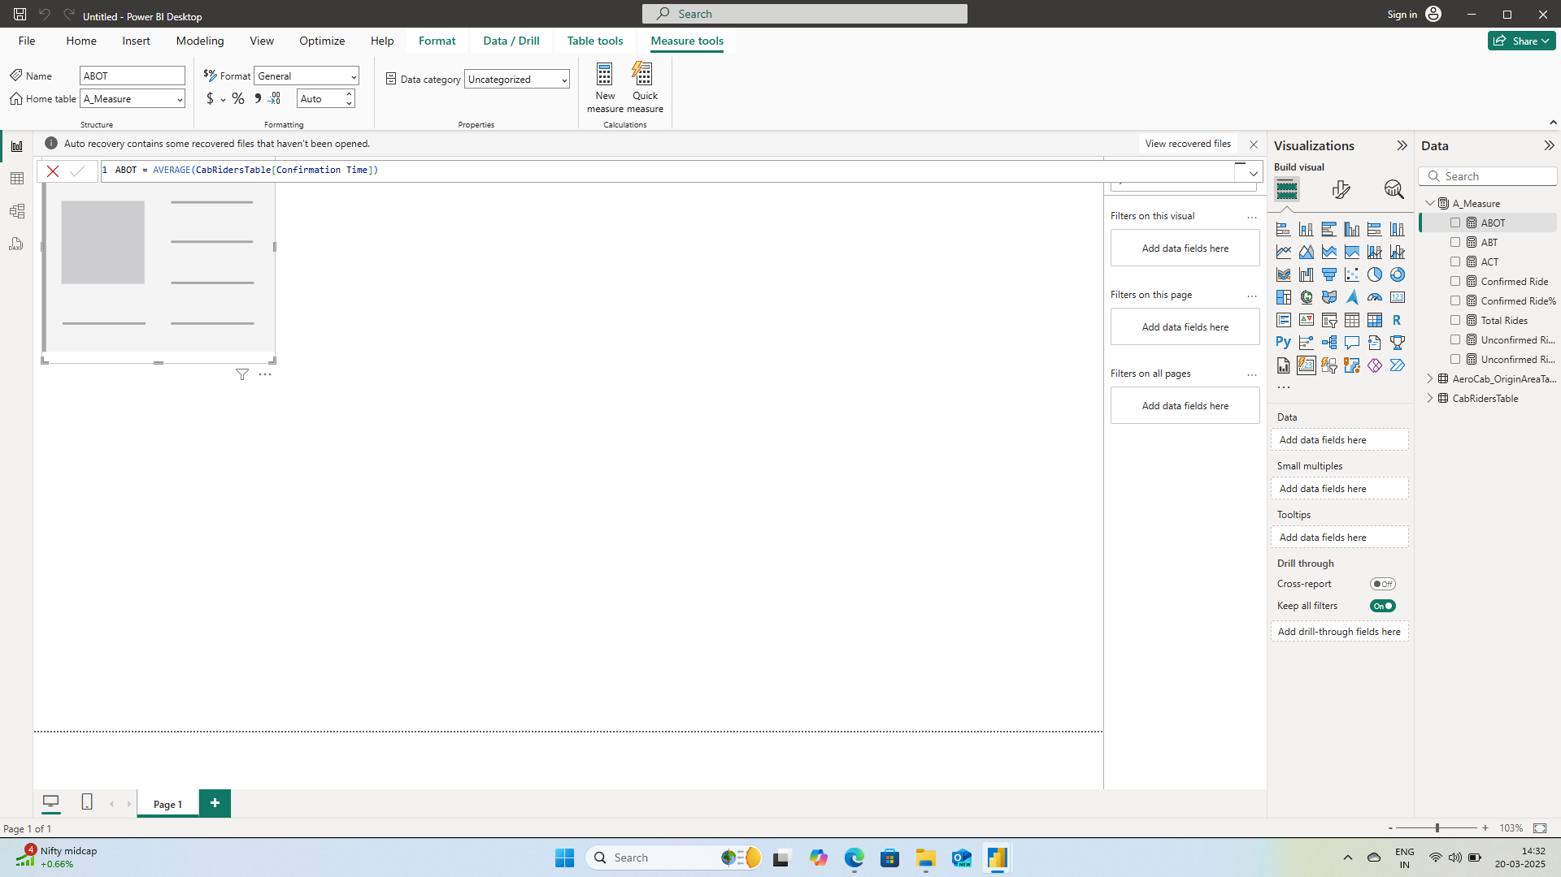

**Task 3**

Share the screenshot of the dashboard as requested in the document.

Answer Screenshot

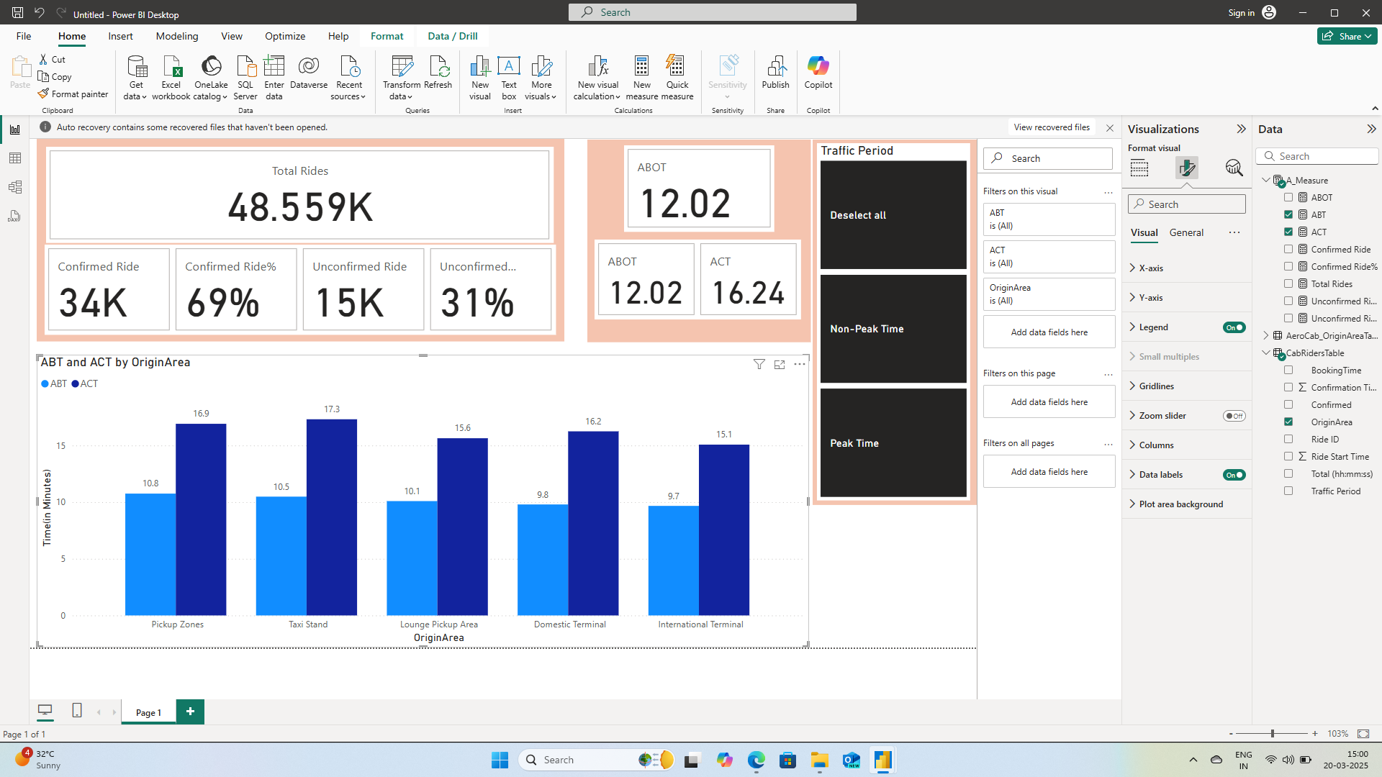

**Task 4**

Share the screenshot of the dashboard as requested in the document.

Answer Screenshot

